Capital Expenditure (CapEx)
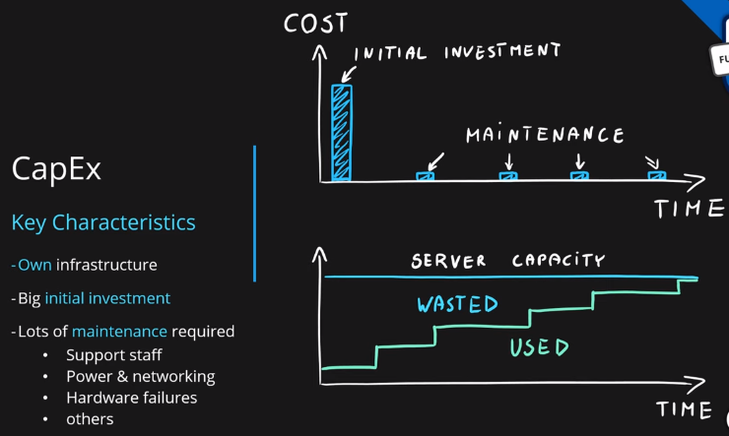

Operational Expenditure (OpEx)
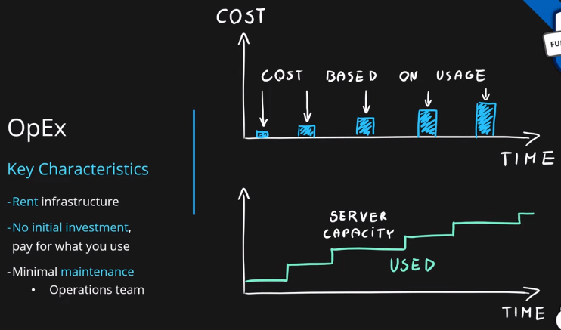

CapEx vs OpEx
Differences between Capital Expenditure and Operational Expenditure
 | Capital Expenditure | Operational Expenditure
Up front cost | Significant | None
Ongoing cost | Low | Based on usage
Tax Deduction | Over time | Same year
Early Termination | No | Anytime
Maintenance | Significant | Low
Value over time | Lowers | No change

